Cutting Edge Advances in Nanomedicine-Based Approaches to Cancer Treatment
Abstract: Cancer remains a highly serious disease, making the development of more effective treatments extremely important. Traditional cancer therapies, such as chemotherapy, radiotherapy, and surgery, play a major role in managing cancer, but they face several limitations. These include drug resistance, poor drug solubility, and difficulties in specifically targeting tumour cells, which together reduce the overall success of treatment. Nanomedicine offers a promising new direction in cancer therapy. It enhances the specificity, effectiveness, and tolerability of treatments by using nanoparticles to deliver drugs directly to tumour cells. This review discusses the mechanisms and benefits of nanoparticle-based drug delivery, focusing on both passive and active targeting approaches. Additionally, the review highlights how nanomedicine can improve various cancer treatment techniques, including surgery, chemotherapy, immunotherapy, radiotherapy, photodynamic therapy, photothermal therapy, gene therapy, and tumour diagnosis and imaging. The future of nanomedicine in cancer treatment looks highly encouraging. However, further progress is needed to reduce toxicity, improve drug delivery efficiency, enhance carrier stability and controlled drug release, simplify nanoparticle design, and develop advanced manufacturing technologies. Overall, the integration of nanomedicine into cancer therapy holds tremendous potential to transform cancer treatment and improve outcomes for patients.
Keywords: Cancer, Nanomedicine, Targeted drug delivery, Chemotherapy, Radiotherapy, Immunotherapy, Gene therapy.
1. Introduction: Nanomedicine is an advanced approach that uses very tiny materials, called nanoparticles, to improve cancer treatment. These nanoparticles can be made from different substances such as liposomes, solid lipid particles, polymers, silica, carbon, or metals. Each of these materials has unique properties that make them useful in fighting tumours [1].
One major advantage of nanoparticles is that they can deliver drugs directly to tumour cells, which helps reduce damage to healthy tissues. They also protect the drugs from breaking down too early, ensuring that the medicine reaches its target effectively [2]. Additionally, nanoparticles can release drugs in a controlled and steady way, making the treatment more precise and efficient. Because of their extremely small size, these particles can easily enter and spread throughout tumour tissues, which improves the overall effectiveness of the therapy. Nanoparticles can also enhance imaging techniques, helping doctors to see tumours more clearly. Others can be used in special treatments such as photothermal therapy, where the particles are heated to destroy cancer cells. Furthermore, nanomedicine allows for more personalized treatments, meaning that therapies can be adjusted to suit the specific needs of each patient [3].
Overall, nanomedicine offers a promising and innovative approach to cancer treatment by making it more targeted, effective, and less harmful compared to traditional methods like chemotherapy and radiation. According to the International Agency for Research on Cancer (IARC) Global Cancer Statistics 2022, there were approximately 20 million new cancer cases worldwide, of which 2.3 million were female breast cancer cases—making it the second most commonly diagnosed cancer globally. While lung cancer was the most frequent overall, breast cancer was the most common in women in 157 countries. Globally, breast cancer caused around 670,000 deaths in 2022. Effective medical interventions are therefore urgently needed to reduce the overall cancer mortality rate. Conventional cancer therapies, such as surgery, chemotherapy, and radiotherapy, have been successful in improving survival in numerous patients. However, they show limited efficacy in the treatment of advanced metastatic cancers. Although immunotherapies represent a breakthrough in the management of advanced cancers, their clinical success is limited by low patient response rates. Most importantly, both conventional chemotherapy and immunotherapies are non-targeted cancer treatments that often destroy tumour cells at the expense of normal cells, leading to undesirable and sometimes fatal side effects. As a result, targeted drug delivery systems (TDDS) these are smart drug delivery method that send medicines directly to cancer cells instead of affecting the whole body [4].
Active targeting helps nanoparticles enter cancer cells but does not always assist them in reaching the tumour in the first place. Passive targeting relies on the enhanced permeability and retention (EPR) effect, where leaky tumour blood vessels allow nanocarriers to accumulate in tumours more than in normal tissues [5]. Active targeting, on the other hand, involves decorating nanocarriers with molecules that specifically recognize and bind to receptors on cancer cells. In recent years, nanomedicine has gained significant attention due to its ability to overcome many of the limitations of traditional treatment methods. It uses extremely small particles, usually between 1 and 100 nanometres in size, which can be designed with special properties to interact effectively with the body [6]. These nanoparticles can help deliver drugs directly to tumour cells, reduce harm to healthy tissues, and improve the overall effectiveness of cancer treatments.
Common types of nanomedicines include liposomes, polymeric micelles, and polymer–drug conjugates, which are widely studied for their clinical applications. Compared to traditional small-molecule drugs, nanomedicines can carry both hydrophilic (water-loving) and hydrophobic (water-hating) drugs. They also circulate in the bloodstream for a longer time, release drugs slowly, increase the amount of medicine reaching tumours, and reduce side effects [7]. However, despite these advantages, some nanomaterials—such as carbon nanotubes and dendrimers—still raise safety concerns and have not yet received approval from the Food and Drug Administration (FDA) due to toxicity issues. Therefore, although nanomedicine shows great promise in improving cancer diagnosis, imaging, and treatment, further research is needed to address safety challenges and enhance its effectiveness in targeted drug delivery.
2.Importance of Nanomedicine:
Tumours grow rapidly and need more oxygen and nutrients. To obtain these, tumours create new blood vessels; however, these vessels are often leaky and abnormal. Because of these leaks, large molecules and tiny particles can slip out of the blood into the tumour more easily than into normal tissues [8]. Tumours have leaky blood vessels and poor drainage, which allows nanoparticles with the right size, shape, and surface properties to enter and remain inside the tumour more effectively than in normal tissues.
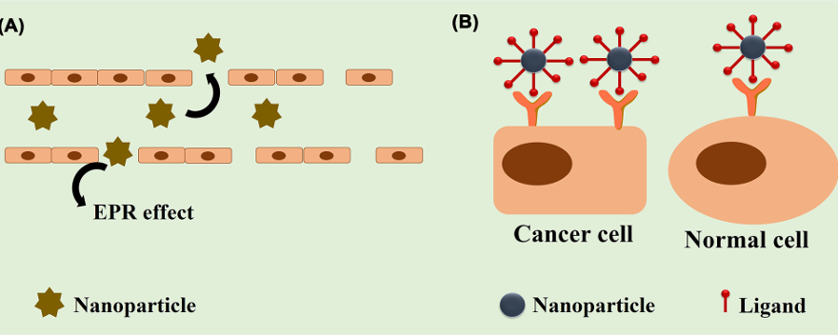
Figure 2.1 Targeting strategies of nanoparticles
illustrating (A) the passive targeting (enhanced permeability and retention effect or EPR effect) and (B) the active targeting into a tumor. In passive targeting, nanoparticles extravasate through the leaky blood vessels of tumor vasculature having gap sizes of 100 nm to 2 μm. Dueto poor lymphatic drainage, nanoparticles home at the tumor site. In active targeting, targeting ligands are attached to the nanoparticles that specifically target cancer’s overexpressed receptors. The optimal size range to perform the EPR effect is 20–200 nm. Source: Chakraborty et al. [13].
This phenomenon is known as the EPR effect (Enhanced Permeability and Retention). It helps deliver cancer drugs directly to tumours by using nanoparticles that pass through the leaky blood vessels and stay within the tumour. Nanoparticles sized between 50–150 nanometres work best. Nanoparticles with a neutral or slightly negative charge are preferred because they avoid getting trapped in the wrong places. Ligands such as antibodies, peptides, aptamers, and nucleic acids can be attached to nanoparticles. These ligands are designed to bind specifically to receptors that are found in large numbers only on cancer cells. For example, transferrin is a protein in the body that carries iron. Cancer cells often need more iron, so they have a higher number of transferrin receptors. When nanoparticles enter the bloodstream, proteins from the blood can stick to their surface and form a layer called the protein corona.

2.1 Nanomedicine Strategies Targeting Primary Tumours
The primary tumour represents the initial site of malignant transformation and proliferation, where cancer cells form a localized mass before spreading to other parts of the body. Traditional cancer treatments such as chemotherapy, radiotherapy, and surgery have made substantial progress in improving patient survival; however, these approaches often lack specificity and result in severe side effects due to the destruction of healthy tissues.
Nanomedicine has emerged as a powerful approach to overcome these limitations by using nanoparticles as carriers for therapeutic agents. The strategies employed by nanomedicines to target primary tumours can be broadly categorized into passive targeting, active targeting, and stimuli-responsive targeting mechanisms.
Passive Targeting:
Passive targeting is based on the Enhanced Permeability and Retention (EPR) effect, a unique physiological phenomenon observed in solid tumours. The blood vessels in tumour tissues are highly irregular, with large fenestrations ranging from 100 to 800 nanometers—significantly larger than those in normal tissues. Furthermore, the lymphatic drainage in tumours is often poorly developed or absent, preventing the efficient clearance of macromolecules from the tumour interstitium.
Active Targeting:
Active targeting involves the modification of nanoparticles with specific ligands that can recognize and bind to overexpressed receptors on the surface of tumour cells or tumour-associated endothelial cells. Once the nanoparticle binds to its target receptor, it can enter the cell through receptor-mediated endocytosis, thereby delivering the therapeutic agent directly inside the tumour cell.
Stimuli-Responsive Targeting:
In addition to passive and active targeting, modern nanomedicines are often designed to respond to specific stimuli present in the tumour microenvironment (TME). These stimuli-responsive nanoparticles, also called “smart nanocarriers,” release their therapeutic payload in response to internal or external triggers.
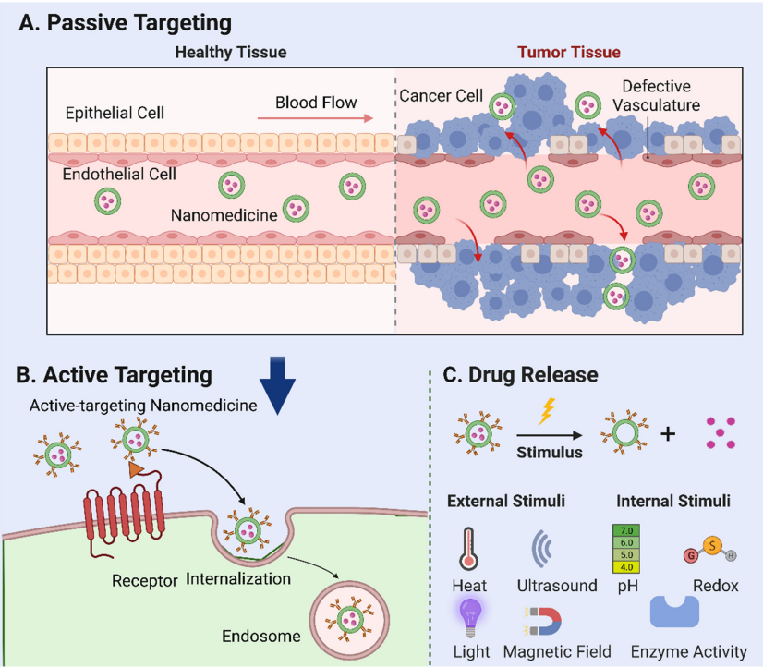
Figure 2.2 Mechanisms of nanoparticle-mediated drug delivery. (A) Passive targeting: the accumulation of nanomedicine in tumour tissues based on their specific physical and chemical properties phenomenon known as the “enhanced permeation and retention (EPR) effect”. (B) Active targing: the use of ligands or antibodies to target tumour cell surface receptors. Following internalization endogenous particles are transported to the nuclear endosome, where further particle process and drug release occur. (C) External stimuli, such as temperature, ultrasound, light, magnetic field internal factors, including pH, redox reactions, and enzyme activation, that can be employed to trigger the release of drugs loaded in nanoparticles. Source: Xu et al. [1].
3.The Role of Nanomedicine in Tumor Therapies:
Nanomedicine is the use of very tiny materials, called nanoparticles, to make cancer treatments more effective and precise. These nanoparticles can be made from different materials, such as liposomes, solid lipid nanoparticles, polymeric micelles, dendrimers, mesoporous silica nanoparticles, quantum dots, carbon nanotubes, and metallic or magnetic nanoparticles.
These nanomaterials have several special advantages. They can deliver drugs directly to the tumour, which helps the treatment target cancer cells more accurately while reducing harm to healthy cells. They also protect the drugs from breaking down before they reach the tumour, allowing the medicine to stay active for a longer time. In addition, nanomaterials can release the drugs slowly and in a controlled way, which provides a more consistent treatment effect [9].
Another important benefit is that nanoparticles can penetrate deep into tumour tissues, something that many regular drugs cannot easily do. They can also assist with imaging and diagnosis, helping doctors to see tumours more clearly. Furthermore, certain types of nanomaterials can be used in new forms of therapy, such as photothermal therapy, which uses heat or light to destroy cancer cells.
Nanomedicine also supports personalized medicine, meaning that treatments can be customized for each patient based on their unique needs.
Overall, nanomedicine offers exciting new opportunities to improve cancer treatment. It has the potential to make existing methods—like surgery, chemotherapy, radiation therapy, and immunotherapy—more effective and safer. By using nanotechnology, doctors may be able to achieve better treatment outcomes and improve the quality of life for cancer patients.
Nanomedicine uses very tiny materials called nanomaterials to make cancer treatment more effective and precise. These nanomaterials include liposomes, solid lipid nanoparticles (SLNs), polymeric micelles (PMs), dendrimers, mesoporous silica nanoparticles (MSNs), quantum dots (QDs), carbon nanotubes (CNTs), and metallic or magnetic nanoparticles (NPs).
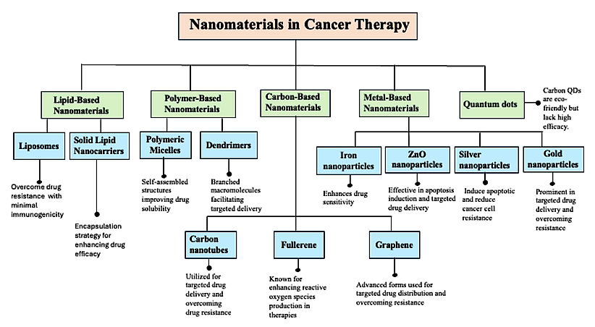
Figure 3.1 Illustration of the diverse classes of nanomaterials (NMs) used in cancer therapy, highlighting their specific types (e.g., liposomes, dendrimers, metallic nanoparticles, polymeric NPs), primary biomedical applications, and mechanisms of action. These include enhancing targeted drug delivery, improving drug solubility and bioavailability, and overcoming multidrug resistance in cancer cells. Source: Sabir et al. [10].
These special materials can carry cancer drugs directly to the tumour, help the drugs stay stable for longer, and release them in a controlled way. This makes the treatment stronger and reduces harm to healthy cells.
Nanomedicine can also be used in many types of cancer treatments, such as surgery, chemotherapy, immunotherapy, radiotherapy, photodynamic therapy, photothermal therapy, gene therapy, and in detecting and imaging tumours. Overall, nanomedicine is transforming the way cancer is treated. It helps doctors target cancer cells more accurately, improves the effectiveness of existing treatments, and better recovery and quality life for patient.

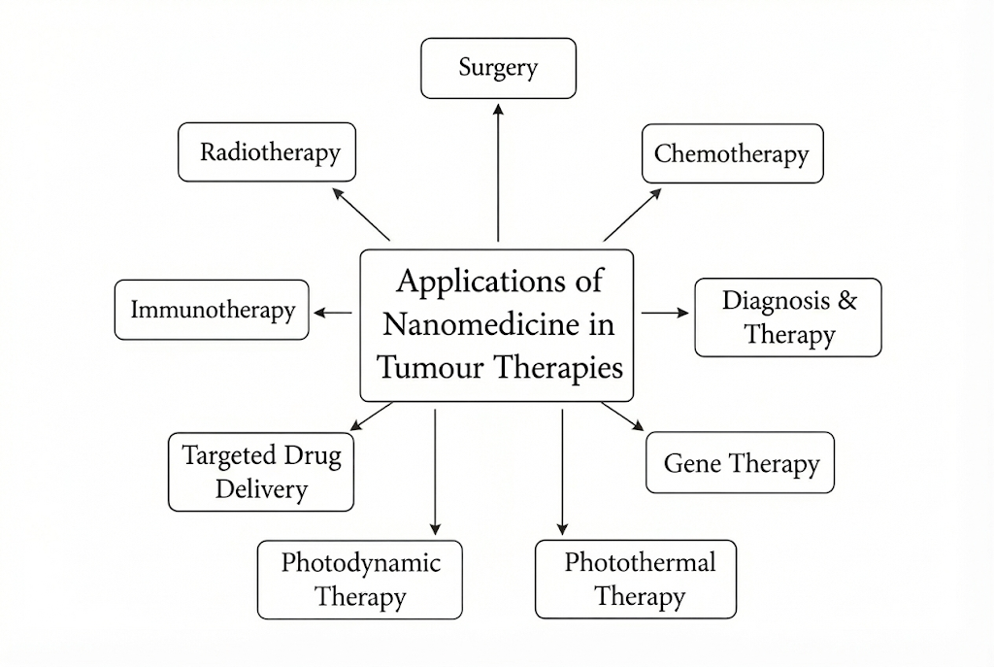
Figure 3.2 Applications of Nanomedicine Tumour Therapies.
3.1 Surgery:
In traditional surgery, doctors often need to remove diseased tissues, which can sometimes cause damage to the healthy tissues around them. Nanomaterials help make surgery safer and more effective by allowing quick control of bleeding and improving visibility during the procedure. For example, researchers developed a special gel made from carbon nanotubes and chitosan, which can quickly stop heavy bleeding. This helps surgeons manage deep or severe bleeding more efficiently, improving patient safety during surgery.
Another major challenge in surgery is that very small tumours are often difficult to see with the naked eye. Nanotechnology helps solve this problem by making it possible to highlight tumour edges and nearby important structures. This allows surgeons to clearly see the boundaries of the tumour and avoid damaging surrounding healthy tissues. Nanomaterials can also help locate lymph nodes that may contain cancer and label any remaining cancer cells that are too small to be seen easily. This improves the accuracy of tumour removal.
Scientists have also developed nanoparticles that glow under near-infrared light, which helps doctors clearly see tumours such as ovarian cancer during surgery. Other nanoparticles can work in two ways: they serve as MRI contrast agents to show tumours in scans and as fluorescent probes that make tumours visible during surgery. These tools make it easier for surgeons to identify and remove cancerous tissues completely [11].
In addition, nanoparticles can improve a type of treatment called cryosurgery, which kills cancer cells by freezing them. Nanoparticles help control how cold spreads through the tissue, make the freezing process more precise, and reduce harm to healthy areas. For example, adding magnesium oxide nanoparticles (MgO NPs) to tumour cells improves their ability to conduct heat, which makes the freezing process more effective.
3.2 Chemotherapy:
Chemotherapy is a common treatment for cancer, but it has some major problems. It is not specific to cancer cells, so it can also harm healthy cells, causing side effects and discomfort. Chemotherapy drugs are often removed from the body quickly, which means patients need repeated treatments. Over time, cancer cells can become resistant to the drugs, making the treatment less effective.
Nanoparticles can help solve these problems. They can be designed to target only cancer cells and accumulate at the tumour site. This allows the medicine to work better while reducing harm to healthy cells. Nanoparticles can also use the special conditions of the tumour environment, such as acidity, low oxygen, enzymes, or specific receptors on cancer cells, to release the drugs directly where they are needed.
Nanoparticles can also carry multiple drugs at the same time, even if the drugs have different properties. This can make treatment stronger and more effective. Using multiple drugs together can help kill cancer cells, prevent tumour growth, and modify the tumour environment to improve therapy.
3.2 Radiotherapy:
Radiotherapy is a common cancer treatment that uses high-energy X-rays to destroy cancer cells. However, its effectiveness is often limited because many tumours have low oxygen levels, which makes the cancer cells more resistant to radiation. Additionally, some tumour cells that are farther from the radiation source receive weaker doses, reducing the treatment’s overall impact.
Nanotechnology has been explored as a way to overcome these challenges. Nanoparticles can carry and deliver oxygen directly to tumours, increasing the sensitivity of cancer cells to radiation. They can also act as radiosensitizers, enhancing the damage caused by radiation by increasing cell death, promoting DNA damage, and weakening the cancer cells’ protective mechanisms.
3.3 Immunotherapy:
Immunotherapy is a cancer treatment that helps the body’s immune system fight tumours, but it is effective in only a small number of patients. Nanotechnology can help make immunotherapy work better. Nanoparticles can improve the delivery of cancer-fighting substances and boost the activity of immune cells against tumours. They can also change the tumour environment to make it easier for the immune system to attack cancer cells.
Furthermore, nanoparticles can help trigger cancer cell death in ways that strengthen the immune response. They can also be used to deliver multiple treatments at once, enhancing the overall effect and helping the body overcome the ways tumours avoid the immune system.
3.4 Gene therapy:
Gene therapy is a modern way to treat cancer by changing or fixing the genes inside our cells. Instead of using only medicines or radiation to kill cancer cells, gene therapy works by correcting the problems in the genes that cause cancer to grow.
Cancer happens when some genes in our cells do not work properly. The genes that normally stop cancer (called tumour-suppressor genes) may stop working, and the genes that make cells grow too fast (called oncogenes) may become too active. Gene therapy tries to fix these problems by adding healthy genes, turning off bad genes, or helping the body’s immune system to find and kill cancer cells.
To put the new genes into cancer cells, scientists use special carriers called vectors. These vectors act like delivery vehicles that carry the genes into the right cells. Some vectors are made from viruses, which are changed so they cannot cause disease. These work very well but can sometimes cause side effects. Other vectors are non-viral, such as tiny nanoparticles made of fat, gold, or polymers. These are safer and can be designed to target cancer cells more accurately. They also protect the genes from being destroyed in the body and help them reach the right place.
4.Approved Nanomedicines: Advancing Cancer Therapy in the Clinic
Several nanomedicine-based cancer therapies have already been approved by the U.S. Food and Drug Administration. These advanced formulations help deliver drugs directly to cancer cells, reduce side effects, and improve treatment efficiency.
1.Doxil is a liposomal form of the chemotherapy drug doxorubicin. It is used to treat breast cancer, ovarian cancer, and certain types of blood cancers.
2.Myocet is another liposomal doxorubicin formulation. It is mainly used for the treatment of metastatic breast cancer.
3.DaunoXome is a liposomal daunorubicin. It is used to treat blood cancers such as Kaposi’s sarcoma and leukemia.
4.Abraxane contains paclitaxel bound to albumin nanoparticles. It is used for breast cancer, lung cancer, and pancreatic cancer.
5.Onivyde is a nano liposomal form of irinotecan. It is approved for the treatment of pancreatic cancer.
6.Vyxeos combines two chemotherapy drugs, cytarabine and daunorubicin, inside liposomes. It is used for acute myeloid leukemia (AML).
7.Hensify (NBTXR3) consists of hafnium oxide nanoparticles. It is used along with radiotherapy for soft tissue sarcoma to enhance radiation effects.
8.Pazenir is another nanoparticle formulation of paclitaxel used for breast, pancreatic, and lung cancers.
9.NanoTherm uses iron oxide nanoparticles for localized heating therapy (magnetic hyperthermia). It is mainly used for brain, prostate, and pancreatic cancers.
10.Marqibo is a liposomal vincristine formulation. It is approved for the treatment of leukemia [12].

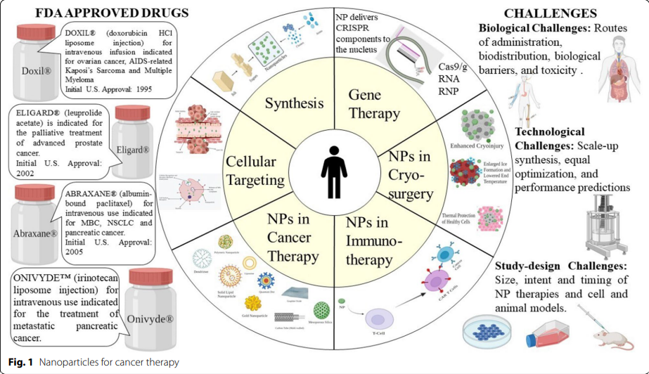
Figure 4.1 Nanoparticles for cancer therapy
Source: Gavas et al. [2]
5. Amalgamation Nanomedicine for Cancer Immunotherapy:
Cancer immunotherapy is a major modern breakthrough in cancer treatment. It works by using the body’s own immune system to identify and destroy cancer cells. Instead of directly attacking the cancer like chemotherapy or radiation, immunotherapy strengthens or activates immune cells so they can naturally fight tumours.
History of immunotherapy: The idea of using the immune system to fight cancer is not new. William Coley, known as the father of immunotherapy, was the first to attempt treating cancer through the immune system. However, this field gained major scientific attention much later when James P. Allison and Tasuku Honjo received the Nobel Prize in 2018 for their discoveries in cancer immunotherapy. Their work led to new treatments that help remove the “brakes” from the immune system, allowing it to attack cancer more effectively.
A famous example is Judy Perkins, a woman with stage IV metastatic breast cancer, who became the first person to be completely cured using immunotherapy.
Types of immunotherapies:
Current cancer immunotherapy methods include cytokine therapy, antibody-based therapy, and adoptive cell therapy.
- Cytokine therapy boosts the activity of immune cells using natural signalling proteins.
- Antibody-based therapy uses lab-created antibodies to target specific proteins on cancer cells.
- Adoptive cell therapy involves collecting a patient’s immune cells, improving or modifying them in the lab, and putting them back into the body to fight the tumour [13].
Amalgamation Nanomedicine Approaches:
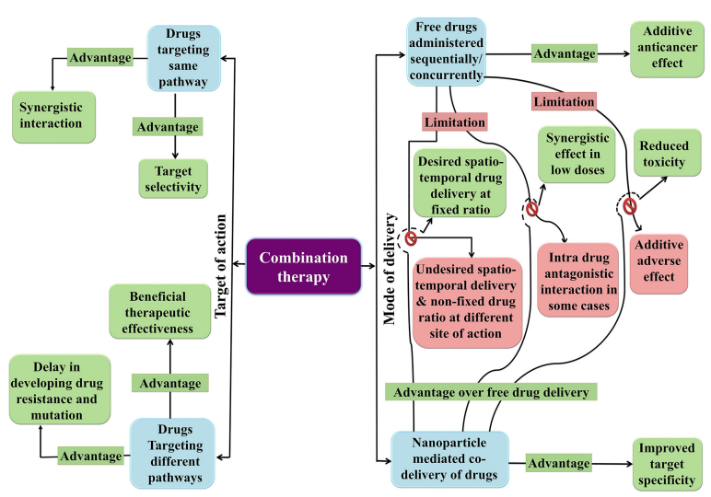
Figure 5.1 Rationale of nanoparticle-mediated combination therapy for cancer
Combination therapy has been divided according to the target of action and mode of delivery. The figure represents the individual advantages of targeting same and different signaling pathways and the advantages of co-delivery over free drug delivery. Source: Chakraborty et al. [13].
1. Radiotherapy Combined with Immunotherapy
Scientists have developed advanced nanomedicines capable of delivering both radiation and immune-stimulating drugs simultaneously. These nanomedicines carry radioactive materials that directly target the tumour, enabling localized radiation to destroy cancer cells while also activating the immune system. This dual mechanism enhances tumour destruction and reduces the likelihood of cancer recurrence.
Radiotherapy not only kills cancer cells but also improves immune system function. When radiation destroys tumour cells, it releases small fragments of cancer proteins known as tumour antigens. These antigens help the immune system recognize and attack the remaining cancer cells. In addition, radiotherapy increases the infiltration of immune cells, such as T cells, into the tumour area and modifies the tumour microenvironment to make it less suppressive. As a result, radiotherapy significantly enhances the effectiveness of immunotherapy, leading to stronger and more durable anti-tumour responses.

2. Chemotherapy Combined with Immunotherapy
Combining chemotherapy and immunotherapy is a promising strategy to improve cancer treatment outcomes. Chemotherapy kills rapidly dividing cancer cells, while immunotherapy strengthens the body’s immune system to recognize and eliminate tumours. In one clinical study, researchers used a nanoparticle-based chemotherapy drug, Abraxane® (paclitaxel), in combination with an immunotherapy drug, Tecentriq® (atezolizumab), to treat triple-negative breast cancer (TNBC), a particularly aggressive form of the disease. This combined treatment showed encouraging results, demonstrating improved therapeutic efficacy. However, some patients experienced severe immune-related side effects due to an overactive immune response. Scientists suggest that using nanoparticles to deliver these drugs directly to tumour sites can enhance treatment precision, minimize damage to healthy tissues, and reduce the risk of adverse side effects.

3. Photothermal Therapy Combined with Immunotherapy
Photothermal therapy (PTT) combined with immunotherapy is an emerging and effective approach for cancer treatment. In PTT, nanoparticles are administered into the tumour and activated by near-infrared light, generating localized heat that damages cancer cells through protein denaturation, DNA damage, and membrane disruption. Although PTT alone can effectively kill tumour cells, it may not completely eliminate large or deep-seated tumours, which can lead to recurrence. When combined with immunotherapy, the heat generated by PTT not only destroys tumour cells but also releases tumour-associated antigens, which stimulate the body’s immune system. This immune activation enhances the recognition and elimination of residual cancer cells and helps prevent metastasis or relapse. Therefore, combining photothermal therapy with immunotherapy produces a synergistic effect, improving both local tumour control and systemic anti-tumour immune responses.
Conclusion:
Nanomedicine is transforming cancer treatment by delivering drugs directly to tumours, making therapy more precise and reducing harm to healthy cells. Unlike traditional treatments like chemotherapy and radiotherapy, which can damage normal tissues and cause severe side effects, nanomedicine uses tiny carriers—such as liposomes, nanoparticles, dendrimers, and micelles—to carry drugs efficiently. These carriers help drugs stay stable, dissolve better, reach tumours more effectively, and release slowly over time. Nanomedicine also enables new approaches like photothermal therapy, gene therapy, and RNA-based treatments, all designed to specifically target cancer cells. Recently, it has been combined with immunotherapy to boost the body’s immune response against tumours, and with other treatments to improve overall effectiveness. However, challenges remain, including potential toxicity, difficulties in mass production, and uncertainties about how nanoparticles behave in the body long-term. Solving these issues will be crucial for turning nano medicine from research into widely available cancer therapies.

References

[1] | X. H. H. X. G. Manman Xu, "Cancer Nanomedicine: Emerging Strategies and Therapeutic Potentials," Molecules, p. 20, 2023.
[2] | S. Gavas, S. Quazi and T. M. Karpiński, "Nanoparticles for Cancer Therapy: Current," Nanoscale Research Letters, vol. 16, p. 21, 2021.
[3] | K. M. Abdullah, G. Sharma, A. P. Singh and J. A. Siddiqui, "Nanomedicine in Cancer Therapeutics: Current Perspectives from Bench to Bedside," Molecular Cancer, vol. 24, p. 43, 2025.
[4] | L. Lin, W. He, Y. Guo, Q. Zheng, Z. Liang, D. Wu and H. Li, "Nanomedicine-induced programmed cell death in cancer therapy: mechanisms and perspectives," Cell Death Discovery, p. 13, 2024.
[5] | D. Rosenblum, N. Joshi, W. Tao, J. M. Karp and D. Peer, "Progress and challenges towards targeted delivery of cancer therapeutics," Nature Communications, vol. 9, p. 12, 20018.
[6] | J. Hu, P. M. Arvejeh, S. Bone, E. Hett, F. M. Marincola and K.-H. Roh, "Nanocarriers for cutting-edge cancer immunotherapies," Journal of Translational Medicine, vol. 23, p. 36, 2025.
[7] | M. J. Mitchell, M. M. Billingsley, R. M. Haley, M. E. Wechsler, N. A. Peppas and R. Langer, "Engineering precision nanoparticles for drug delivery," Nature Reviews Drug Discovery, vol. 20, 2021.
[8] | D. Fan, Y. Cao, M. Cao, Y. Wang, Y. Cao and T. Gong, "Nanomedicine in cancer therapy," Signal Transduction and Targeted Therapy, vol. 8, p. 34, 2023.
[9] | A. A. K. Navas, N. Doreswamy and J. Francis, "Nanomedicine and Immunotherapy for Cancers," European Journal of Medical and Health Sciences, vol. 2, p. 9, 2020.
[10] | S. Sabir, A. S. B. Thani and Q. Abbas, "Nanotechnology in cancer treatment: revolutionizing strategies against drug resistance," Frontiers in Bioengineering and Biotechnology, vol. 13, p. 20, 2025.
[11] | B. Wang, S. Hu, Y. Teng, J. Chen, H. Wang, Y. Xu, K. Wang, J. Xu, Y. Cheng and X. Gao, "Current advance of nanotechnology in diagnosis and treatment for malignant tumors," Signal Transduction and Targeted Therapy, vol. 9, no. 1, p. 65, 2024.
[12] | P. Samathoti, R. K. Kumarachari, S. P. N. Bukke, E. S. K. Rajasekhar, A. A. Jaiswal and Z. Eftekhari, "The role of nanomedicine and artificial intelligence in cancer health care: individual applications and emerging integrations-a narrative review," Discover Oncology, vol. 16, no. 1, p. 35, 2025.
[13] | K. Chakraborty, A. Tripathi, S. Mishra and A. M. Mallick, "Emerging concepts in designing next-generation multifunctional nanomedicine for cancer treatment," Bioscience Reports, vol. 42, p. 45, 2022.

